MODULE 3–INTRODUCING THE LABYRINTH TO OTHERS

WHAT THIS HANDOUT IS ABOUT

This briefing suggests how you may wish to plan and hold a labyrinth walk, making an assumption that some or all people who come may be new to the labyrinth. Of course, you may also welcome newcomers to a labyrinth walk more informally, however here we assume that you have planned a specific time and place for this purpose.
We cover the following points:

  - Planning needs – audience, available space, timings
  - Choosing the venue
  - Preparing what you say to introduce the labyrinth to others*
  - Back-up resources, e.g. handouts & signage
  - Setting-up and packing away

* Other points that you might want to consider mentioning when you introduce a walk are covered in the module “HOSTING & HOLDING A WALK”.

After working through this module, you should be well placed to answer the question – how can I prepare for hosting a walk, and make this helpful and meaningful for people who may be coming to the labyrinth for the first time?

To work through the module:

  - Read and reflect upon THESE NOTES.
  - Watch the video: https://youtu.be/FKUc968QTwI. [Click on the Settings button in the YouTube video window to select subtitles for your language]
  - Work through the REFLECTIVE EXERCISE.

Remember you can CONTACT US if you have any questions, or reflections that you’d like to share.

1. PLANNING NEEDS

The following are among normal tasks for planning a labyrinth walk:
- Confirming arrangements with the venue’s organizer, if appropriate. Making sure that the space available is sufficient, if you will be bringing a temporary labyrinth to lay out. You may also wish to check that the venue is accessible for people with wheelchairs, or who may have special needs (for example, whether seats may be available for them). If the event is to be held after dark: check how well lit the venue is, and whether you will need to make any special provision for this.

- If you wish to use candles to ring the labyrinth, you may need to check what fire regulations may be in place, and whether these are allowed. Battery-powered lights might be an alternative.

- Advertising the event; for example, in social media, by word-of-mouth, by mentioning the event to friends, by attaching notices where you are able. The “LABYRINTH POSTER” http://www.labyrinthlaunchpad.org/Lab_Wlk_Posterv01.pdf handout may be useful for this purpose (blank space is included to write in the day, time, and venue for your walk).

- Making sure that you will have available anything that you need for the walk–the labyrinth itself, but possibly other items too (see 4. RESOURCES, below).

- Thinking through what you may want to say, and how you will host the walk. The notes in this module and in “HOSTING & HOLDING A WALK” http://www.labyrinthlaunchpad.org/LAB_FAC_TRG_HOSTING_HOLDING_SPACE_v01.pdf will help you with this.

2. VENUE

Where you host a walk may be indoor or outdoor. Check that sufficient space is available for laying out the labyrinth, if you plan to create or lay out a temporary one. Also check that the surface where the labyrinth will be laid is relatively flat, if outdoor. If planning an outdoor walk, consider whether you might make contingency arrangements in the event of bad weather, or have a means to inform people that a walk is canceled, if you decide to postpone it.
When creating or siting a temporary labyrinth, you may have a feeling where the labyrinth should go, and where its entrance or exit should be sited. Some people like to site labyrinths using dowsing, although this need not be something that has meaning for you. Practicalities, such as where the entrance will give the easiest access and be most inviting for walkers, may be your main consideration.
Where possible, it’s best to avoid setting up a labyrinth close to high-powered electricity wires, or where there is a lot of noise or vibration. Labyrinths may sit very well upon grass, stone, close to trees, or near water.

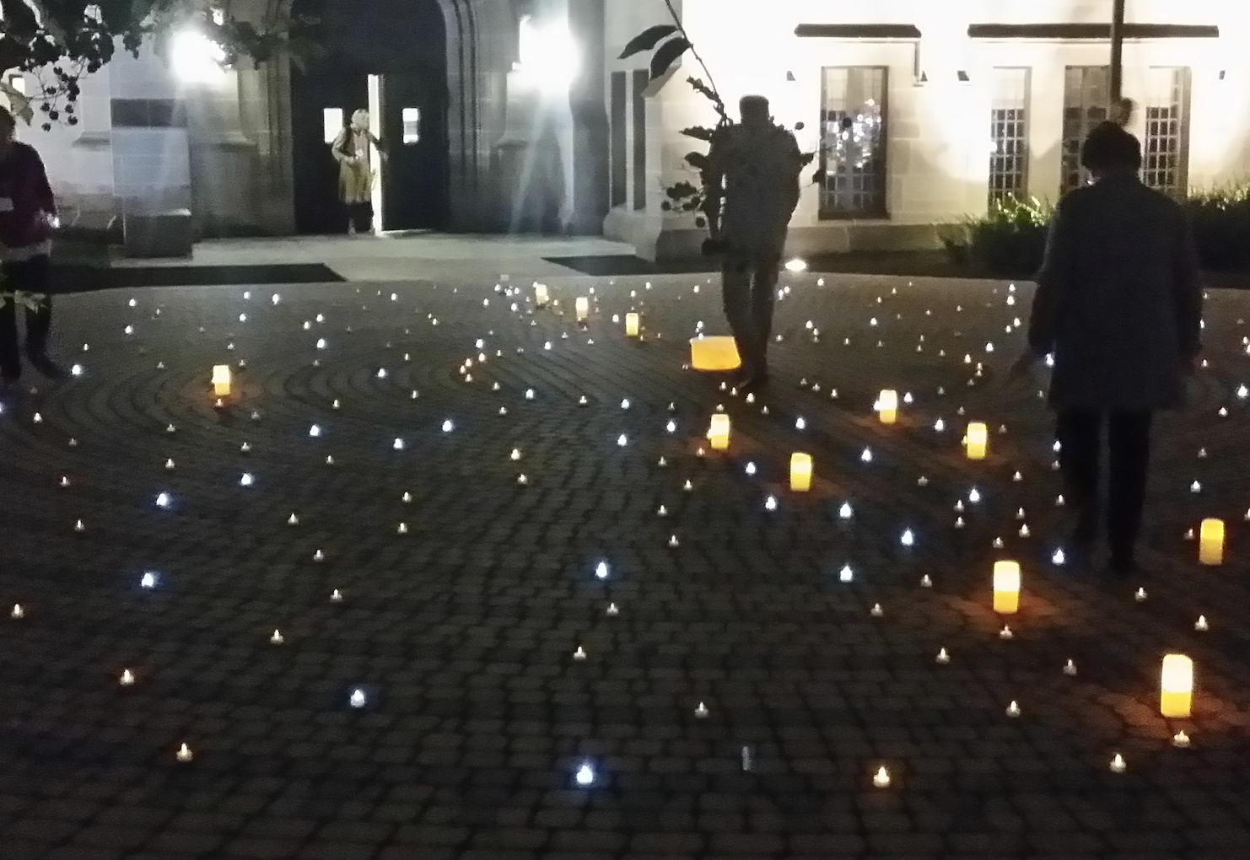

Labyrinth walks accompanied by battery or solar powered lights can be very special.

3. INTRODUCING THE LABYRINTH

Most people who come to the labyrinth for the first time will be curious to know what it is. It’s therefore useful to say a few words about this before inviting people to start their walk. This need to be no more than a very brief introduction, while you might want to mention where people can find out more in any handout that you offer with the walk, or simply say that you are happy to speak with anyone who may be interested to learn more following the walk.

The following points may be sufficient to mention, especially considering that people would not expect to hear a lecture, nor necessarily have time for that!
  - The labyrinth is a single path, leading to a centre. It is not the same as a maze, which has dead ends and is deliberately meant to be a puzzle to work through. Nothing more is needed in walking a labyrinth than to calmly follow the path.
  - Labyrinths are found in many parts of the world, and have a long history–drawings of labyrinths that are several thousand years old have been discovered. Labyrinths have been found across many different cultures.
  - Today, labyrinths are very common in many places–in parks, schools, hospitals, and elsewhere. Often, they are offered just as a place for people to enjoy a brief time of quiet, reflective meditation, or simply to step away from their busy lives for a short while.
  - Labyrinths come in many shapes and sizes. The one that you will walk today is (say what type; for example, a ”Classical” type).

Note: Apart from introducing what the labyrinth is, points that you might want to consider mentioning when you introduce a walk are covered in the module “HOSTING & HOLDING A WALK” http://www.labyrinthlaunchpad.org/LAB_FAC_TRG_HOSTING_HOLDING_SPACE_v01.pdf. Suggested points may wish to mention are also included in the handout “INTRODUCING A WALK–CHECK-LIST” http://www.labyrinthlaunchpad.org/Intro_Walk_Check_v01.pdf.

4. RESOURCES

The minimum that you need to hold a walk is a labyrinth and yourself. This is perfectly adequate. However, some hosts like to offer other resources, which can sometimes help enhance the experience of those who come to a walk.
The following are among possibilities that you may wish to consider having available, although all of these are ”optional extras”:
  - A bell, chime, or some other means to indicate when you open and close the labyrinth. This can be especially useful when you want to bring a walk to close, and individuals are still walking. Ringing a bell gently at increasing frequency can be effective as a means for alerting people that the walk is drawing to a close (although you can simply start speaking gently to mention this as an alternative, perhaps saying something like “we are coming to our close soon. When you are ready, please start to make your journey out from the labyrinth”).
  - A pack of cards containing words or quotations for reflection by walkers that can be left by the entrance to the labyrinth. Walkers can be invited to take a card to reflect upon during their walk, if they wish. You may wish to create cards of your own, or write suggested words on small pieces of paper that walkers can take–perhaps including such themes for reflection as ”Gratitude”, ”Unity”, and “Harmony.”
  - A finger labyrinth, if you have one or have made one– or paper versions that individuals who can’t easily, or do not wish to walk the larger labyrinth can use.

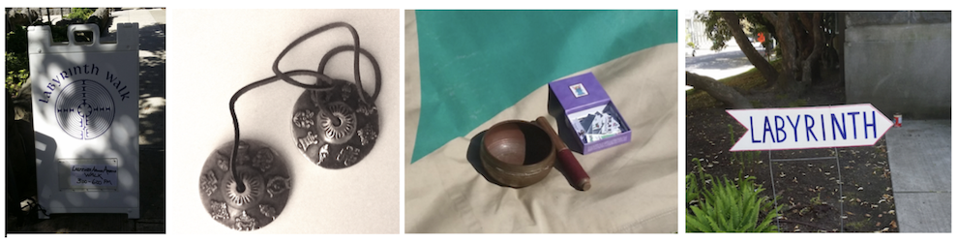

Chimes, signs, and cards are among possible accessories to bring for a labyrinth walk

  - Handouts to offer to walkers, including any latecomers. A single sheet of paper should be sufficient to describe what the labyrinth is, suggested approaches for walking, and any follow-up information such as your contact details for anyone who wants to learn more.
The” WALK HANDOUT” http://www.labyrinthlaunchpad.org/Lab_Wlk_Handoutv01EN.pdf provides an example. You are free to use, add, or to change this in any way that you wish.
  - Signs–usually written on card or strong paper. These might point people to where the walk is happening, mention that anyone who is passing by is welcome to join, and indicate where people may leave financial contributions (If relevant).
  - Musical accompaniment. Some hosts like to play a CD or even arrange for a musician friend to play quiet, meditative music while people are walking the labyrinth. Check if a license is needed to play public music (your venue may have this, if one is needed).
  - Candles, a means for lighting them, and candleholders. Having a ring of candles circling the labyrinth, or other means of providing simple and subtle lighting can enhance nighttime labyrinth walks. This can take some time to set up and pack away, so if you plan this, it may be helpful to have a friend or other person who can help you with this task, and be sure that the candle wax won’t drop on the labyrinth itself, and that all flames are extinguished before you leave. Ensure that you’re aware of, and comply with, any fire regulations for the venue.
  - Paper and pencils for writing or drawing. Some people like to Journal their experiences following their walk. Having materials available that they can use to record their thoughts or to make a drawing can be helpful.
  - Napkins. Walking the Labyrinth can be an emotional experience for some, although generally hopefully a happy one. Having a small box off napkins available may be welcome for some.
  - Scarves. Scarves or pieces of light fabric can be offered to anyone who wants to have something to hold, wave, or otherwise use to express themselves while they are walking.
  - A basket, box, or bowl for collecting any financial contributions that individuals are happy to make toward the cost of the labyrinth or for hiring the venue (if relevant).
  - A “Comments Book,” for walkers to note they reflections if they wish. If people wish to stay a while following their walk, you may also like to ask them how they felt about their experience, although without offering them any criticism or judgment. If friends have walked or helped you hold the walk, you may also like to ask them for any comments they may have that might help you with future walks, such as anything that wasn’t clear to them that could usefully have been mentioned.
  - A pen and paper for people to add their names and contact details if they’re happy for you to keep them informed about future walks and any other events that you may organize (this may be especially helpful if you are planning regular walks within your community).

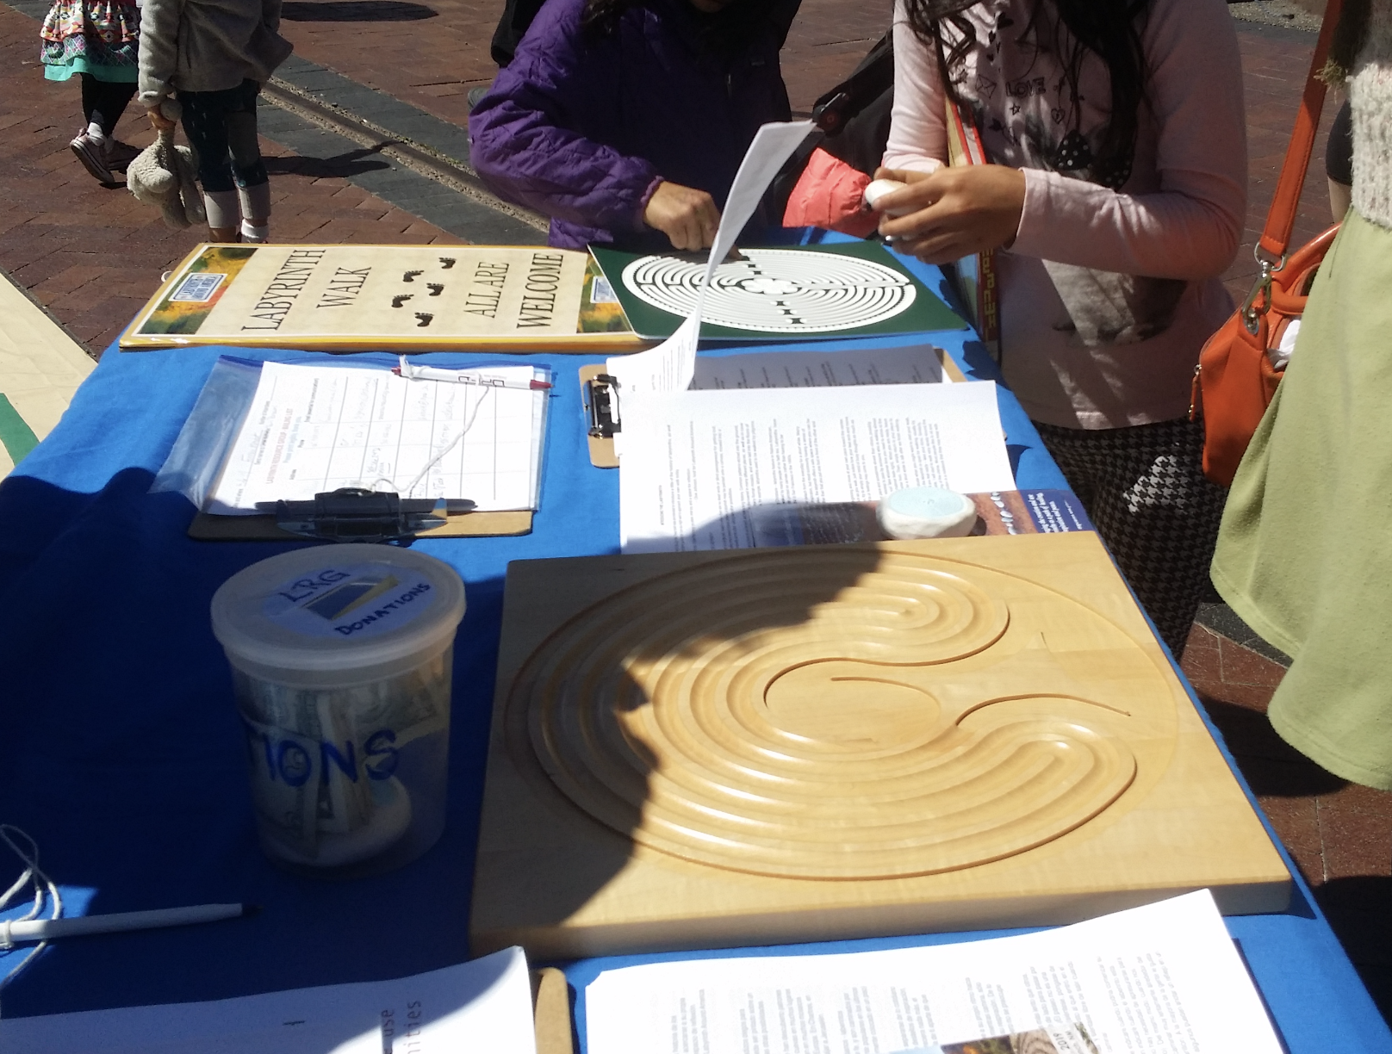
Handouts, finger labyrinths, a collection box, signs–all are among
“optional extras” that some hosts like to bring to a walk

5. SETTING-UP & PACKING AWAY

If you are creating a temporary labyrinth, then you will obviously need to plan a little time to put this in place before the time you plan to start the walk. Similarly, laying out a labyrinth painted on canvas or some other material may take a little time, especially if chairs or other furniture need to be moved in the place where you are hosting the walk.
Even if you are using a labyrinth that is permanent, it’s sensible to allow at least 15 minutes before the planned start of the walk, in order to welcome people as they arrive, and allow yourself time for any set up that may be required.
If you have borrowed a temporary labyrinth and are laying it out for the first time, be careful to note how it is folded, so that you will be able to pack it away in the same way. If you have made or own a mobile labyrinth, you might like to lightly mark on its back where folds should go, e.g. using marker tape.
Following the walk, allow yourself time to pack away or dissemble the labyrinth (If appropriate). This usually takes a little longer than for setting up. Before doing this, you may wish to have a broom handy to sweep the labyrinth clean and remove air bubbles as you fold it, and then to clean the floor once the labyrinth has been packed away (when indoors, moving back chairs and tidying up any litter left by walkers, may also be necessary). Sweeping a labyrinth is also good to do when you first lay it out.
Make sure ahead of time that you know any arrangements for locking up the venue, if no one else is available to help, and if appropriate.

GOING FURTHER

HANDOUTS that may help:

- LABYRINTH POSTER http://www.labyrinthlaunchpad.org/Lab_Wlk_Posterv01.pdf

- LABYRINTH WALK Handout http://www.labyrinthlaunchpad.org/Lab_Wlk_Handoutv01EN.pdf

- INTRODUCING A WALK–CHECK-LIST http://www.labyrinthlaunchpad.org/Intro_Walk_Check_v01.pdf

