HURA NA LABYRINTH

ICYO IYI NYANDIKO IRI KUVUGAHO (IGAMIJE)

Iyi nyandiko irasobanura ikanatanga intangiriro kuri labyrinth. Muri iyi nyandiko musangamo:

  - Icyo labyrinth aricyo, ndetse n’inshamake y’amateka yayo
  - Kubera iki labyrinths ari ingenzi (ari ngombwa)
  - Ni gute wakora Labyrinth ndetse ukanagira n’ubunararibonye ku bijyanye na Labyrinth
  - Ni gute watangiza cyangwa wamenyekanisha labyrinth ku bandi.

DUSHAKIRE ku rubuga rwa:www.labyrinthlaunchpad.org, niba hari ibibazo ushaka gusobanuza, inyunganizi watanga cyangwa andi makuru washaka kudusangiza.

1. ESE LABYRINTH NI IKI?

- Labyrinth niinzira imwe rukumbi igeza umuntu uri kuyinyuramo mu ruziga hagati (Centre). Ikidashimishije muri icyo gishushanyo cy’ubugeni gifite inzira nyinshi, ni uko nta nzira zifunze ndetse nta n’aho uhindura ubwoko bw’inzira kuburyo byatuma utakara ukabura iyo ujya. Ibi bitandukanye n’ubundi bwoko bw’inzira bugenda bwinyuranamo (spiral) kuko bwo mu nzira yabwo haba harimo aho inzira igera igafatana cyangwa bigasaba guhindukira.

- Iyi nzira ishobora kuba ari ugusiga amarangi ahantu, gukata ibyatsi aho biri ugaragaza iyi nzira, gutondekanya amabuye ukurikije iyi nzira, gusasa amabuye aconze anasize neza, cyangwa n’ubundi buryo wabona kuko ntibubarika. Labyrinths zishobora gushyirwa ahantu mu buryo bwa burundu, cyangwa mu buryo butari ubwa burundu. Labyrinths zimukanwa, akenshi ziba zarashushanyijwe ku kintu cy’umutako runaka cyangwa ikindi gikoresho icyo aricyo cyose, kuburyo cyabikwa kikagendanwa ahantu hose. Zishobora kuba ziri mubipimo bitandukanye, harimo n’intoya ushobora kwicara ukazinyuramo ukoresheje urutoki rwawe.

- Labyrinths ziboneka mu bice byinshi bitandukanye by’isi, kandi zifite amateka y’igihe kirekire. Inzira zigaragara ko zisanzwe zishushanyije hasi, zagaragajwe mu mabuye ashashe ahantu, cyangwa zashyizwe ku nkuta z’amazu zavumbuwe mu bice byinshi bitandukanye.Nk’ikimenyesto rusange cyabayeho cyera na vuba bigaragarako gifite imbaraga mu buryo bwiza ku umuntu uwo ariwe wese ugikoresha, labyrinth ifatwa nk’uburyo abantu bitwara ndetse nk’ikintu kituvugisha ku rwego rugoye gusobanura mu buryo bufatika.

- Labyrinths zaramenyekanye cyane mu bihe bitandukanye mu mateka. Labyrinth nyinshi zagaragaye mu bishushanyo by’amabara by’ubugeni bya Roma, mu kinyejana cya 13, hari nizagiye zishyirwa mumibare mu byumba byaza kiriziya nziza zo mu majyaruguru y’u Burayi.

- Labyrinth ntabwo ari izabo mumuco runaka cg abafite imyemerere runaka,ingero nyinshi zagiye zigaragara mu migabane itandukanye ariko intego cg impamvu zayo zagoranye kumvikana.
Labyrinth zakoreshwaga nko mu birori cyane nk’ahantu hahuriye abantu benshi. Inyinshi muri zo zakoreshwaga mu kuzigendamo mu gihe cy’umutambagiro(pererinaje)ariko ubu inyinshi zikoreshwa muburyo busanzwe bwo gutekereza no kwitekerezaho nk’akaruhuko gato mu gihe wari ufite ibintu byinshi byo gukora, kandi birebana n’ubuzima bwa buri munsi.

Umumaro w’ingenzi wa Labyrinth

- Mubitekerezo byagutse bya John W.Rhodes mu nyigo 16 yakozeho ubushakashatsi ku ingaruka nziza zo gukunda cg gukora labyrinth yongeyeho ibitekerezo bikomeye ko kugenda muri Labyrinth cg urugendo rwa Labyrinth rutanga inyungu nyinshi.

- Ibikorwa byibanda kukubaka umuryango mugari byagize akamaro kanini mu matsinda n’ imiryango itandukanye aho bakoreshaga Labyrinth, harimo za labyrinth zagaragaye muri za kaminuza, mubitaro, no kubibuga by’ibigo bitandukanye.

Gukoresha Labyrinth

- Labyrinth zikoreshwa ku mpamvu zitandukanye. Hari mugukemura amakimbirane, mugufasha abantu mugukemura ibibazo byabo, mugukiza cyangwa kuvura ibikomere ndetse nibijyanye n’imitekerereze, mukubakaamatsindan’ imiryango. Ariko izizwi cyane zakoreshwaga n’umuntu kugiticye, nk’aho ari ahantu hamufasha gutekereza, kwitekerezaho cyangwa se nko gushobora gutera intambwe uva mubyari biguhugije ugashyira ubwenge ku gihe mu gahe gato.

- Haratekerezwa ko hari labyrinths zirenze ibihumbi bitanu (5000 labyrinths) muri leta zunze ubumwe z’Amerika gusa. Inyinshi murizo ni labyrinth zigendanwa. Izisize amarangi zikozwe mumikeka cg izikozwe mubindi bikoresho. Icyo gitekerezo cyagizwe cyane kubera igikorwa cya Rev. Dr.Lauren Astress,wamenyekanye mu gukoresha ibikoresho bya labyrinth kuri katederari y’abagiriki niyo muri San Francisco mu 1990.Ako gashya cyangwaubwo buvumbuzi bwahise bukundwa ndetse bituma habaho gukora cyangwa kurema labyrinths zirenga ijana zisa nizo muri Amerika.

- Izindi labyrinths nyinshi zihoraho cg ziramba nazo zagiye zubukwa n’ amatsinda runaka, insengero, ibitaro, mu migi runaka, ahantu rusange imodoka zihagarara, muri za gereza ndetse no mumashuri. Hari ahantu henshi labyrinths zishobora kuboneka.

- Uyu munsi , abantu benshi bagenda muri iyi nzira(Labyrinth) mugutekereza, no kwitekerezaho, mugushyira ubwenge ku igihe, abandi baba bashaka kwitandukanya n’ibibagoye bahura nabyo buri munsi, abantu benshi biyumva nkaho bazamutse bateye indi ntambwe mubyiyumviro,ariko cyane cyane labyrinth nyinshi zigira ubusobanuro bw’amahoro mu gihe bayigendamo. Ntakindi itanga, Labyrinth itanga umwanya mwiza utekanye aho ushoborakuba uri umwe wenyine kugiti cyawe.

2. AMOKO YA LABYRINTHS

- Izi nzira ziba ziri mu buryo cg amoko atandukanye ndetse n’ingano zitandukanye,bamwe batanze ibitekerezo koizi nzirazitandukanye zishobora kugira ingaruka muburyo butandukanye kubantu bazigendamo bakagira ibyiyumviro bitandukanye mumitekerereze yabo. Rimwe na rimwe izi nzira(Labyrinth) zigaragara nkaho zakozwe zifite umwihariko n’intego yihariye mu bitekerezo.

- Labyrinth ntabwo igihe cyose ziba ari uruziga cyangwa se n’utuyira twazo ngo tube tugororotse igihe cyose. Zishobora kugira amakorosi, urugero nink’inyubako za katederari zo muri Amiens, muri France na Ely, no mu Bwongereza. Ikindi labyrinth ishobora kuba nk’urukiramende cyangwa ifite ishusho y’ibinyampande bitandukanye, gusa ushobora kumenya niba uyirimo cyangwa niba uri inyuma yayo, ariko byose iyo babigendamo baba bagana mo hagati.

- Ibishushanyo byinshi bya labyrinth, ibizwi cyane nink’ibyo muri za kiriziya za cyera bigenda binyuranamo byerekeza aho zigenda zigaruka .Hari izitwa Labyrinth z’ibirori ziba zihurirwamo n’abantu benshi zigira inzira zitandukanye zijyamo hagati nizisohoka hanze. The “Baltic Wheel”n’ imwe mu bwoko bw’izo Labyrinths. Nka Labyrinth z’ibirori ziba zarateguwe harimo nk’izi bita “Ritualistic dance”cyangwa izijyanye n’ibirori runaka byo kubyina.

- Rimwe na rimwe biragoye gusobanura impamvu zituma bashushanya muri ubu buryo, nko gukora inzira mu biti, cyangwa gukora mubinyampande n’ingano zitandukanye biterwa ahanini n’ibibuga bashushanyamo uko bingana.
- Iza cyera (rimwe na rimwe bazita “Cretan”). Izo hagati (harimo nizo mu ikinyejana cya 11 zagaragaye muri Katederari yo muri France) na Baltic Wheel, izo labyrinth zagiye zigaragara cyane.

Labyrinth eshatu zamenyekanye cyane

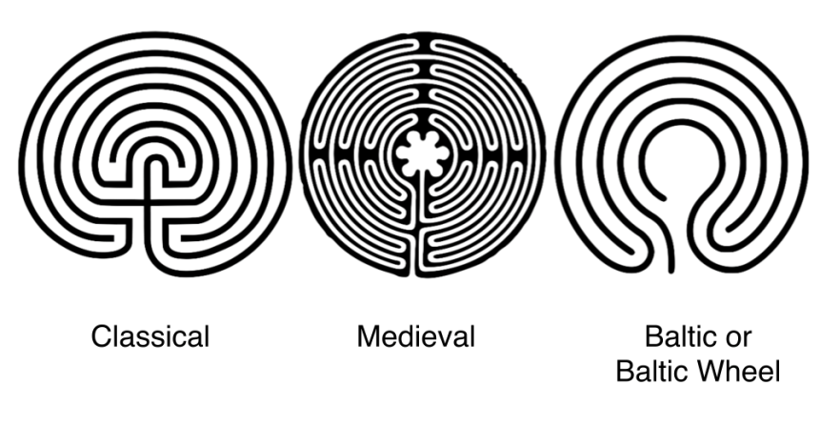
- Izindi ni nka (‘’Man in the Maze”zamenyekanye cyane kubasangwabutaka bo mumiryango yo muri America). Igitangaje rero ni uko zagaragaye nk’izikomeye kuzishushanya kimwe n’iyi yo mubwoko bwa Classical,ariko imyinshi muri ubwo bwoko zagaragaye ahantu henshi hatandukanye mu mateka. Byagaragaye ko abantu batandukanye bagiye bazishushanya bagize ubumenyi busa bwihariye. Ibyo rero byaratangaje.
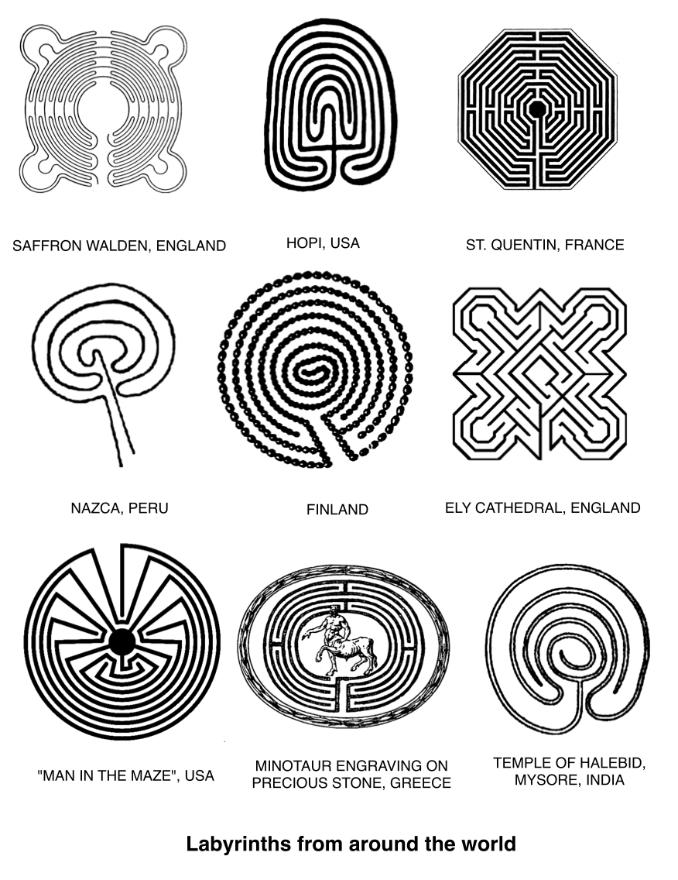

3. IBICE BYA LABYRINTH

- Ushobora kubona hari ubudasa bw’ inyito bukoreshwa mugusobanura ibice bya labyrinth, ibi bikurikira ni bimwe bigenda bisa n’iby’ahandi.

  - Inzira : unyuramo ujya muri centre

  - Kurwinjiriro cg kurusohokero, ni ahantu dutangirira intambwe twinjira cyangwa dusoreza intambwe dusohoka. Aho utangira kugirana umubano n’intego ikujyanye muri uru rugendo.

  - Hagati _Ahantu hubashywe tugera iyo twakurikiye iriya nzira y’urugendo. Hagati rimwe na rimwe tuhahuza no kuza murugo cyangwa kurangiza urugendo, cyane cyane ubwoko bw’aba Tohono O’odham bizerako iyo ugeze hagati ni nk’aho uba ugeze murugo

  - Kimwe mubigize uru rugendo ni uko ari urugendo rw’ubuzima nk’uko abantu bamwe babyizera
Kuza mo hagati bigaragarira bamwe nko kuza ahantu h’ubumwe, h’amahoro, ubusabane, ubucuti cyangwa se ugeze ahantu h’ubutsinzi mubuzima
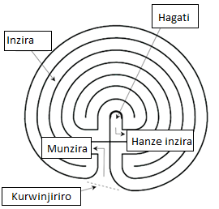
Ibice bya Labyrinth

4. URU RUGENDO USHOBORA KURUGENDA UDAKORESHEJE IBIRENGE

- Kugenda urugendo rw’urutoki: Ni uburyo bumwe bushoboka ku bantu bafite ahantu hatoya cyangwa bafite ubumuga bwo kutagenda muri labyrinth. Muri uru rugendo inzira ziba zishushanyije ku mpapuro, kubintu bikomeye cyane cyane bikozwe mubiti, bikozwe mumabumba cyangwa se bikoreshejwe ibindi bikoresho runaka, noneho ubusobanuro bwabyo buba ari ukunyuzamo urutoki mumwanya w’ibirenge cyangwa amaguru.

- Labyrinth yakorwaga y’urutoki ntabwo yakeneraga ibiti cyangwa amabuye. Inzira zashushanwaga ku gipande cy’urupapuro yabaga ifite intego, ntabwo ari nk’ibyo babaga baradoze kubitambaro cyangwa ibyo bashyiraga kubikuta (cyangwa se aho bogera mugihe habaga hari igikorwa kidasanzwe nko muri Nottingham Univerity) byabaga bikozwe n’indodo cyangwa ubwoya bw’intama, ibipande by’amakarita cyangwa rimwe na rimwe byabaga biri kumucanga.

- Labyrinth zakorwaga no mu mabumba, zikadodwa no mubiringiti byampande enye bikagabanwamo udupande tw’intoki two gukiniraho. Labyrinth kandi bashoboraga kuzishushanya bakazisiga amarangi, bakabikora kubikuta ikaba yagendwamo, atari gusa kuyinyuzamo urutoki ariko kandi ukaba wayikurikira ukoresheje amaso. Muby’ukuri ntagarukiro (iherezo) wakoresha mukurema (Kubaka) labyrinth.

5. INCAMAKE Y’AMATEKA YA LABYRINTH

- Labyrinth ifite amateka maremare, ariko turabyoroshya, kuko ntituzi amateka y’abakurambere yose uko ameze kandi haracyakorwa n’ubundi buvumbuzi bushya.
- Muri make amateka ya Labyrinth tuyamenyera ku inkuru cg umugani ukomoka kuba giriki bo mu mugi wo muri Athene , Theseus aho yafashije umukobwa w’umwami wa CretanKing Minos, Igikomangomakazi Arianne wo mu bugirikiakabashagutsinda ubwoba abantu bahoranaga ubwoyabashaga kwica Monster yabaga muri centre ya labyrinth yari igoye kwikuramo, kuberako iyo bayigendagamo bakagera muri centre ntibabonaga inzira yo kubagarura inyuma.Iki gikomangomakazi (princess) yifashishije agapira kari k’umugozi kugirango abone uko asohoka muri Labyrinth yahoraga itera ubwoba abantu bashaka kuyigendamo. Nyuma yuko iyo monster ipfuye abantu bose bahise batinyuka kugenda muri iyo Labyrinth.
- Labyrinth zo mumateka zarizitandukanye nizo tugendamo kuko iza cyera zabaga zifite inzira nyinshi, kuburyo uzigendamo ukaba wabura naho waturutse cyangwa ukabura uko uzisohokamo ariko iz’ubu zigira inzira imwe ijya mo hagati kandi igasohoka. Nubwo yaba ifite nzira irenze imwe yo kwinjiriramo biba byatewe nuwayishushanyije inzira iyo ariyo yose yabasha cynagwa ibasha kukugeza mo hagati.

- Mu bihugu bitandukanye byateye imbere bamenye gukoresha labyrinths mu gihe kimwe n’icy’abagiriki. Urugero, nk’amateka y’abhinde, abasore bakiri bato, batekerezaga uko bakora urugamba n’uko bashoboraga gutsinda abanzi babo, ariko ntibagarukaga. Labyrinth z’abahinde zamenyekanye kundimi zabo nka Sansnrit ariyoChakra-vyuha (literally, ‘wheel-battle formation’) yabonekaga mumisozi yo muri Tanric na Jain.

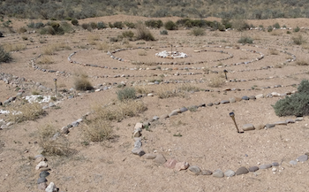
Labyrinth ya chakra-Vyuha ifite hagati hizengurukanije n’ impeta 3 zirimo hagati.

- Mu bihe bya kera labyrinth zakorwaga mumabuye yarambikwaga kubibugacyangwa bakaziconga neza nk’amakaro cyangwa ubundi bugeni bakabishyira hasi mu nzu cyangwa bakazubakira muduti dutoya mu buryo bw’akarima (garden) zagaragaye nk’izahanzwemu Burayi mugihe cya Renaissance.

- Muri rusange kuva mugihe cy’abaroma labyrinth zafatwaga nk’ahantu ho kurindwa. Habaga ari ahantu hizewe kandi hafite umutekano, ahantu ho gutekerereza no kwitekerezaho bigafasha kugera no guhura n’ubuzima bw’imbere mubitekerezo.

- Ingero z’inzira yo mu bwoko bwa Classical (Classical pattern) zaboneka mu nyandiko za kera nko muri Jain, Hindu, naBuddhist, ndetse no mu bishushanyo by’ubugeni biboneka muri Java, Nepal, na Afghanistan.

- Labyrinth zo mu bwoko bwa petroglyphs ( ziconzwe mu mabuye manini) ziboneka muri Galicia, Amajyaruguru y’Uburengerazuba bwa Espagne zakomeje gutekerezwa ko ari izo mu bihe by’ahabanza h’imyaka ya Bronze (early Bronze Age), ndetse inzira zazo zagaragaye mu nyandiko z’abanyababuroni kandi iyo zihabwa igihe zishyirwa mu bihe bimwe n’ibyo. Ingero zo mu bihe bya Etruscan nazo zaragaragaye.

- Abenshi mubanyamerika kavukire (Native American) bafata Labyrinth nka Mama w’isi, nk’aholabyrinth ibaha ubuzima, abantu bitwa Hopi ni bumwe mu bwoko bw’abanyamerika bafata labyrinth nk’aho ari uburyo bwo kongera kuvuka mu buryo bw’umwuka bubafasha kuva mu isi imwe bajya muyindi.

- Labyrinth zitandukanye zagiye zigaragara kandi mumajyaruguru ya Amerika aho babaga barazishushanyije kubitare, habaga harimo naza Labyrinth zifite aho kwinjirira habiri n’inzira zazo zikaba ari nkinziga zagaragaraga nk’inzu y’ibitagangurirwa (yirebe aho hasi), izo bazitaga “Man in the Maze” zabaga ari nk’ikimenyetso cy’ubwoko bw’aba Tohono O’odham.

- Ikigaragara niuko Labyrinths zifite amateka maremare cyane, maremare cyane ndetse aruta ayanditse mumateka yazo.

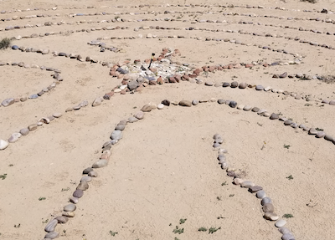

labyrinth yitwa “Umuntu-mu nzira- ishushanyije” , Ifite aho kunyura no guhindukirira hagari kandi hatandukanye

- Mu Burayi, labyrinth yo muri Katederaril ya notre Dame ya chartres muri France (ifite mumyaka mirongo 80 mu majyepfo y’uburengerazuba bwa paris) izwi cyane nkiyihariye, ni labyrinth nan’uyumunsi bakinyuramo uhereye nko mukinyejana cya 13.

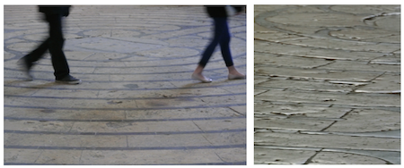
Labyrinth ifite imyaka 800 iherereye kuri Katederari ya Chartres muri France
N’uyu munsi ynyurwamo

Labyrinthos (http://www.labyrinthos.net/ - http://www.labyrinthos.net/): Ni Organization yashyizweho n’abantu bo mumateka ya labyrinth aribo Jeff na Kimberly Saward,ni nko murugo aho kwigira amateka ya Labyrinth.

UMWITOZO: KWITEKEREZAHO

Ibi bikurikira ni ibibazo twatekereje byo gutekerezaho. Nta gisubizo “cy’ukuri” kuri byo icyo uribukore cyose ntacyo gitwaye (kibazo) kandi nicyo gifite agaciro

- Ni iki wavuga igihe hagize umuntu ugusaba kumusobanurira labyrinth icyaricyo nicyo wavuga kumateka yayo?

- Ni gute wabwira amoko akurikira ya labyrinth undi muntu,ugasobanura mu nshamake inkomoko ya labyrinth (a) ubwoko waClassic, (b) ubwoko bwa Medieval?

- Vuga ahantu hatanu 5(inyubako,ahantu rusange, n’ahandi), bishoboka ko wabona labyrinth uyu munsi.

6. AHO WASANGA LABYRINTHS

Labyrinth ziboneka ahantu henshi, kandi hari n’ishobora kuba iri hafi yaho uri ubu ukaba washobora kuyigendamo

Inyinshi ziri ku rutonde rugaragara kuriWorldwide Labyrinth Locator’, https://labyrinthlocator.com/, umuyoboro cyangwa ihuriro rya za labyrinths zizwi ushobora gushakisha kuri internet, winjiye kuri uyu muyoboro ushobora kubona labyrinth iri hafi yaho uri cyangwa se iboneka buri wese yabasha kugendamo.

7. GUKORA LABYRINTH (ITARAMBA CYANGWA IRAMBA)

- Labyrinth ishobora gukorwa muburyo butari ubwa burundu cg uburyo bwa Burundu ikozwe kubuso mu marangi, hakoreshejwe amabara, amatafari, imigozi, amashami y’ibiti cg se ibindi bikoresho ushobora kubona.

- Zishobora kuba barazisize amarangi, ahantu runaka, ku mpapuro za plasitike, nko kuzidoda kumashuka, kuzishyira nko mu mucanga cyangwa mubutaka, kuzishushanya hasi. Zishobora kuba ziri mungano zitandukanye kandi inzira zazo zigomba kuba zijyanye n’ahantu zigiye gushyirwa, urugero: (gushyiraho ibiti cg gukora Labyrinth y’ibiti) gerageza kuba ufite ubuso burambuye uko ushoboye kose, bukaba ari bunini cyangwa burebure kuburyo uzabona aho ushyira izo nzira.

- Mu gihe ushaka gushyiraho cyangwa gukora ziriya nzira witonze ushobora gukoresha irate cyangwa ikindi gikoresho cyagufasha mubipimo cyangwa se ukaba wagereranya ukoresheje ibirenge byawe mugihe ushaka kuba wizeyeko inzira za labyrinth yawe zimeze neza , ushobora no gukoresha icyo twita “Compa “ ukaba wafata inkoni nini ugashyiraho umugozi hanyuma uka zengurutsa ugaragaza inzira , mu gihe ukoresha ubu buryo ushaka undi muntu wo kugufasha kugirango mubikore neza.

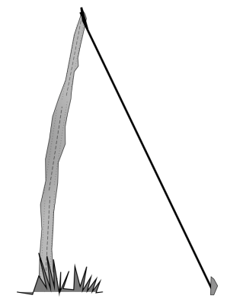

“compa” yoroshye cyane ikozwe mu rudodo n’inkoni cyangwa igiti.

- Kubaka Labyrinth byoroshye ukurikiza intambwe ziri mubishushanyo kuri page ikurikira (ushobora kuyikora kurupapuro cyangwase ukabauyifite kurupapuro rwanditswenamachine, mugihe urimo gukora Labyrinth yawe ku butaka cyangwahasi). Turashimira Jeff Saward ku kuba uwibanze mu kugaragaza zambere yagiye agaragaza muri ibi bishushanyo.

- SEED PATTERN: Igice cyambere ukora kuri labyrinth kizwi nka “Seed pattern Igice cyan mbere mu nkubaka hasi labyrinth cyitwa ‘Speed pattern’:” (Ni ukuvuga kariya gashushanyo k’umusaraba n’utudomo twako). Nk’uko bigaragara muri ibyo bishushanyo biri hasi, mugihe wamaze gushushanya iyi nzira ariyo SEED PATTERN kugenda uhuza ibisigaye bishobora kukorohera cyane

- Nyuma yo gukora cyangwa kurema labyrinth, kandi mbere yo kuyigendamo bwa mbere ni ibintu bisanzwe ko ubanza kuyisabira umugisha kuyisengera cyangwa gusabira ibyiza abantu bose bazaza kuyigendamo.

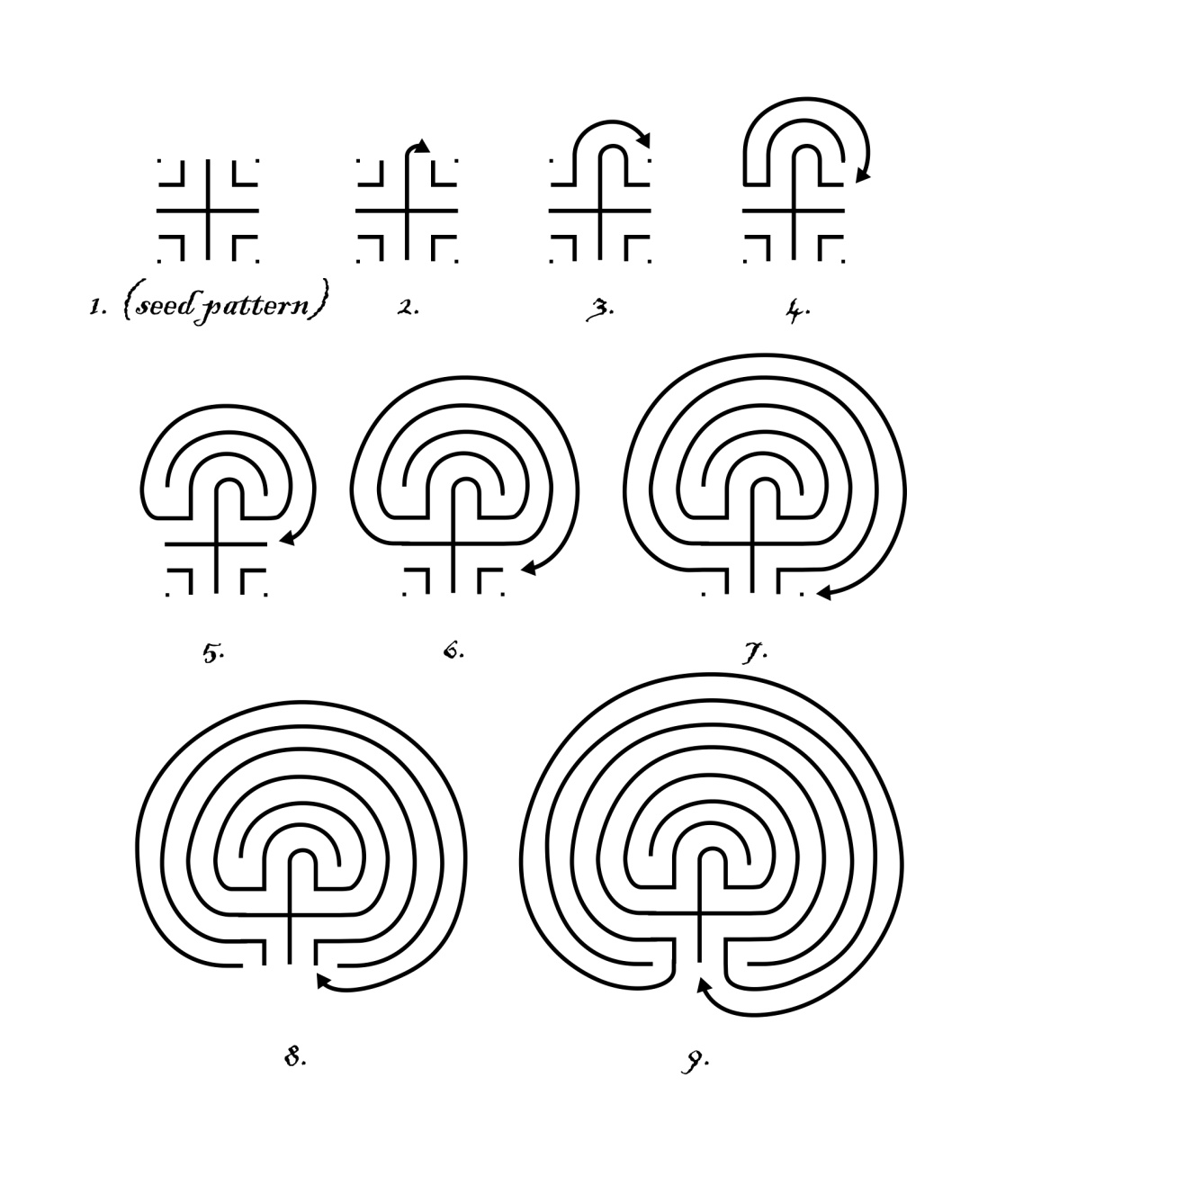

8. KUGENDA MURI LABYRINTH NO GUTEKEREZA KUBUMENYI UYIFITEHO

- Ntabwo hari uburyo bumwe bwo kugenda muri Labyrinth. Ugomba gutangira kwegera iyo labyrinth ufite ikibazo gifunguye kijyanye n’uburyo bw’iyo Labyrinth cyangwa ugaturisha ibitekerezo byawe, ukagerageza kwinjiza umwuka ukawusohora mugihe utera intambwe. Ntutekereze ikintu icyo aricyo cyose mu gihe uri kugenda- ahubwo “ba” uwo uri we kandi witegure kwakira ikintu cyose gishobora kukuzaho cyangwa kukubaho

- Nyuma yo kugenda muri Labyrinth, ni byiza ko utekereza kubumenyi ufite. Ushobora gukenera kugira ibyo kugira ibyo wandika watekerejeho cyangwa no kongera kubitekerezaho neza byimbitse mu gihe runaka.

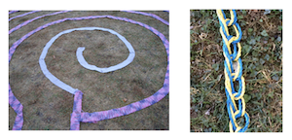
Labyrinth zidoze mumigozi y’ibitambaro (ifoto yafashwe na Carol Maurer)

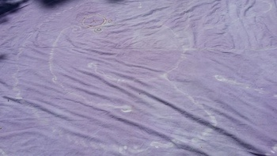

Labyrinth y’amarangi asize kumashuka

UMWITOZO: KWITEKEREZAHO

Ibi bikurikira ni ibibazo ushobora gutekerezaho, nta gisubizo cy’ukuri gihari ahubwo ibyo utekereza nibyo by’ukuri. Gusa ushobora gukomeza kubitekerezaho buri gihe cyangwa kenshi gashoboka.

- Ni ibihe bibazo wibajije ubwawe mu gihe watekerezaga kuri iyi Labyrinth?

- Ni ubuhe buryo bwagutse utekereza ko bwagufasha mu guteza imbere ishyirwa mubikorwa rya Labyrinth?Ni izihe labyrinths ku isi cyangwa mu yindi imiryango migari wakwihuza nayo? Tegura cyangwa shyira mubikorwa!

9. KUMENYEKANISHA LABYRINTH KUBANDI

Inshingano y’uwakiriye abantu ni ingenzi cyane mu guha ikaze no gufasha abaje kunyura muri labyrinth, no kubayobora cyangwa gutuma bishoboka ko habaho kungukira mu buryo butekanye bwiza kandi butunganye muri urwo rugendo

- Gutegura ahantu witeguye gutangira ikaze kubaza kugenda muri labyrinth. Mu rurimi rw’icyongereza igitekerezo cyo “Kwakira”kijya kumera nko gutanga ituze ndetse ni ikaze kubantu baje kuburyo bumva bisanzuye.Mbese kuba umuntu utanga umutekano abantu bakiyumva bari mu rugo iwabo kugirango barusheho kujya baza
- Kubaha ikaze
- Kugeza kubantubashya Labyrinth, harimo no kubakamenyesha uko urugendo rutangira cyangwa rurangira ndetse n’uko bifuza gukora urwo rugendo.
- Kwita kubaje bakerewe, abantu bafite ibyo bashaka gusangiza abandi ubunararibonye bakuye muri urwo rugendo no kwitegereza ibyo aribyo byose biri kuba muri labyrinth. Ibi bivuze muri rusange kugira uruhare runaka bitewe n’ikibayeho.

Muri iyi nyandiko, tugaragaza igitekerezo cya labyrinth nka ”ahantu hera”. Iki gishobora kuba atari igitekerezo cy’ukuri kuri wowe ariko icyo tuba dushatse kuvuga mu buryo bworoshye ni uko kuzamuri labyrinth bitandukanye no kuba ahantu hasanzwe mu buzima bwa buri munsi.

Abantu benshi bemerako labyrinth atari ahantu hera cyangwa hatunganye cyangwa ahantu hadasanzwe ho kwitekerezaho no kwiyungamo imbaraga. Ahubwo ko hagati h’iyo labyrinth aria ho kwisanzurira, hameze nko mu “rugo”, hari umutekano kandi hashyushye.

Mu “mwanya wakirirwamo abantu” nk’uwakira, tuhakirira abantu bashobora kunyura muri labyrinth n’igihe batari mu nshingano zacu kimwe nuko igihe ari abana, ubashinzwe abafasha.

Mu buryo bugari ntabwo inshingano ari ukwivanga mu rugendo rw’umuntu cyangwa “abantu benshi” cyangwa kuba twatuma biyumva badatekanye muburyo ubwo aribwo bwose. “Ukwakira” kw’uwakiriye kugomba kuba koroheje, nta rusaku, utabegereye ndetse kuburyo bitabonwa nabakiriwe

Ntituzi ibyo uyu muntu aba ari gutekereza cyangwa kunyuramo mu gihe anyura muri labyrinth. Muri rusange, abantu benshi bahagirira ibihe byiza bishimishije. Ariko kandi ibyiyumviro byinshi akndi bitandukanye n’ibitekerezo byinshi bishobora kubyuka igihe turi muri labyrinth. Bamwe bishobora kubabera rero ibihe bigoye ndetse bibatesha umutwe.

Gusobanura urugendo

Abantu benshi baza muri labyrinth ku ncuro ya mbere baba bafite anatsiko yo kumenya ibyo aribyo. Rero ni ingenzi cyane kubabwira mu magambo make ibyo aribyo mbere yuko ubaha ikaze bagatangira urugendo rwabo.
Bisaba kutavuga byinshi kurusha uko ubagaragariza muncamake hanyuma bo bakaza kwivumburira byinshi.
Izi ngingo zikurikira ni ingenzi kuzivugaho:
  - Labyrinth niinzira imwe igana mo hagati, ntabwo imeze nka zimwe zigira aho zirangirira, zifungira cyangwa se zinyuranamo.Nta kintu kidasanzwe gikenerwa mu kugenda muri labyrinth kitari ugutuza ugakurikira inzira.
  - Labyrinth zagaragaye mu bice byinshi byo ku isi kandi ifite amateka maremare, ibishushanyo bya labyrinth byo mu myaka ibihumbi byinshi ishize byavumbuwe. Labyrinth zagaragaye ko zigenda zihura n’imico myinshi itandukanye.
  - Uyu munsi Labyrinth zirasa ahantu henshi hatandukanye, muri za parike,mumashuri,ibitaro, n’ahandi hatandukanye. Akenshi ziba zifite cyangwa ziri ahantu abantu baza kwishimisha cyangwa bafata igihe gito gituje cyo gutekereza no kwitekerezaho.Cyangwa se nko gutera intambwe ntoya yo kuva mu buzima bwari bubahugije bagafata akaruhuko.
  - Labyrinth ziri mumoko atandukanye ndetse n’ingano zitandukanye.Imwe dushobora kunyuramo iri mu bwoko bwa “Classical”

Kurangiza urugendo

Muri rusange mugihe cyo gutangira uzabwira abo bakora urugendo muri Labyrinth uko bitwara mu gihe urugendo rugiye kurangira.
Ubu bukurikira ni uburyo bushoboka wakoresha:

- Mu gihe ubonako igihe cyari gitegenyirijwe urwo rugendo cyegereje kurangira, nibyizako uba maso kugirango ubone abantu bakiri mu rugendo (nko kwihuta igihe warimo uzenguruka labyrinth, cyangwa kwihuta uganamo hagati muburyo bwiza udahungabanyije umuvuduko w’abandi bari gukora urugendo)

- Niba mufite inzogera cyangwa ikindi kintu kiraza kuvuga n’ijwi kibamenyeshako igihe cy’urugendo kegereje kurangira, uyu ni umwanya wo kubikora. Irinde gutera urusaku kuburyo bushoboka kuko byabangamira abantu bakiri mu mwanya wo gutekereza cyangwa bakeneye igihe kugirango babashe kugaruka mu mwanya usanzwe.

- Ushobora guhitamo kubagenera inyandiko ngufi ubasomera nk’uburyo bwo gusoza, ndetse ukongera ijwi ryawe nkuko usanzwe ubikora

- Niba abari gukora urugendo batari kugaragaza ko bumvise, bizagusaba kongera kuvuga cyane ubamenyesha ko igihe cyarangiye

UMWITOZO:KWITEKEREZAHO

- Ibi bikurikira ni ibibazo n’ibikorwa twasanze wagerageza ukabitekerezaho kugirango urebe ibitekerezo bishobora kukuzamo cyangwa kukuvamo.Nta gisubizo cy’ukuri gihari icyo aricyo cyose cyakuzamo ntakibazo, ihe akanya gato ko gutekereza kuri ibi bibazo kuko bizagufasha kwemera ibyo ushobora cyangwa udashobora gufasha mugutera inkunga ubumenyi bw’abandi mugihe bagenda cyangwa bakoresha labyrinth.Ushobora kwandika mu ikaye yawe hasi akariko kose kakujemo.

- Guha agaciro iki? Niba hari ikintu, ese igitekerezo cy’uko ari ahantu “hatunganye” cyangwa “umwihariko” gisobanuye iki kuri wowe?

- Tekereza ku myizerere yawe yagutse cyangwa muburyo ko labyrinth ari ahantu hadasanzwe, ni gute wasobanura ibi?

- .Shyira hamwe uturango duto twamamaza labyrinth n’ubwo waba wabyometse kukibaho cyangwa igikuta, gerageza kwirinda gukoresha amagambo menshi, kandi shyiraho n’ifoto ya labyrinth ikurura abashaka kuyimenya.

- Gerageza gushaka ahantu hashoboka hafi y’aho uri hashobora kuba ari heza mu kwakira urugendo rwa labyrinth. Niba ubishaka shaka amakuru ku byangombwa bikenewe kugirango icyo gikorwa kibere aho hantu cyangwa henshi muri aho hantu wabonye

- Niba ubishaka egeranya impapuro zibyo wakoze, bishobora gukoreshwa murugendo. Inyandiko ziriho The LABYRINTH WALKhttp://www.labyrinthlaunchpad.org/Lab_Wlk_Handoutv01EN.pdfishobora gufasha cyane kuri ibi

- Bitewe no guhitamo kwawe, umaze gukora urugendo rwawe, ita cyangwa tekereza ku kintu icyo aricyo cyose wazakora mu bundi buryo igihe uzaba utegura urugendo rw’ubutaha. Ni ibiki byagenze neza, wumva ushaka kongera gukora ubutaha? Ni ibiki wagerageza kongera gukora mu buryo butandukanye n’ubwambere? Saba incuti zawe zikubwire uko zabibonye niba mwari kumwe cyangwa niba zakurebaga mugihe wakoraga urugendo.

10. KUBIJYAMO BYIMBITSE

- Shakisha amahirwe yo kuba wabona ubumenyi burusehokuri labyrinth binyuze mukuyiganiraho n’abandi, usoma ibyo abandi bagiye bavuga mu muryango mugari wa labyrinth ku isi. Urebe amavidewo, usome inkuru cyangwa ibitabo. Hari ingero nyinshi cyangwa aho wakura amakuru henshi, no ku rubuga rwa Labyrinth Launchpad website wahakura amakuru.

- Ushobora kandi gushaka kongera amahugurwa nk’umuntu wakira abandi muri labyrinth , ayo mahugurwa atangwa na Veriditas, wareba kuri uwro rubugahttps://www.veriditas.org/, ndetse n’abandi batanga amahugurwa baru ku rutonde ruri ku rubuga rwa Labyrith Launchpad

- Injira mu umuryango mugari wa labyrinthhttps://labyrinthsociety.org/ku isi. Ushobora kuba umunyamuryango, harimo no kuba umwe mu bakora Labyrinth, Abakira abandi bakeneye Labyrinth ndetse n’ibindi wumva wifuza kumenya. Umunyamuryango kandi ashobora kubona inyandiko za kera, ashobora gushimishwa no gutanga cyangwa gusangira ibitekerezo bye kubintu byose birebana na labyrinth abinyujije ku rubuga nkoranyambaga rwa Society’s Facebook rw’umuryango ( kandi akaba yatanga ikaze kubatari abanyamuryango).

• Andi matsinda ari kurutonde kuri Labyrinth Launchpad website,www.labyrinthlaunchpad.org,amenshi agushishikariza cyane kubaza ibibazo, kuganira n’abandi k’ubumenyi ndetse no gufata imyanzuro kuri Facebook n’izindi mbuga nkoranya mbaga. Urutonde rw’ibitabo, inkuru, imbuga zitandukanye, ndetse n’amakuru ari ku ikoranabuhanga ushobora kubibona kuri iyo link.

